RXPL Backend Making Process
Step 1 : Post the Excel Data into MongoDB
- Making the Hierarchy data
TLM -> SLM -> FLM -> MR
- Excel sheet post the excel with “Postman” and it stores the hierarchy in the Database

Step 2 : Create the Matches
- Excel Data has the StartDate and EndDate and the playerAID and PlayerBID
- Create the Schema part and put the Data into the Database with the Name as “Matches” Collections
- Match the PlayerID-A and PlayerID-B and create the matches as per the Excel Sheet

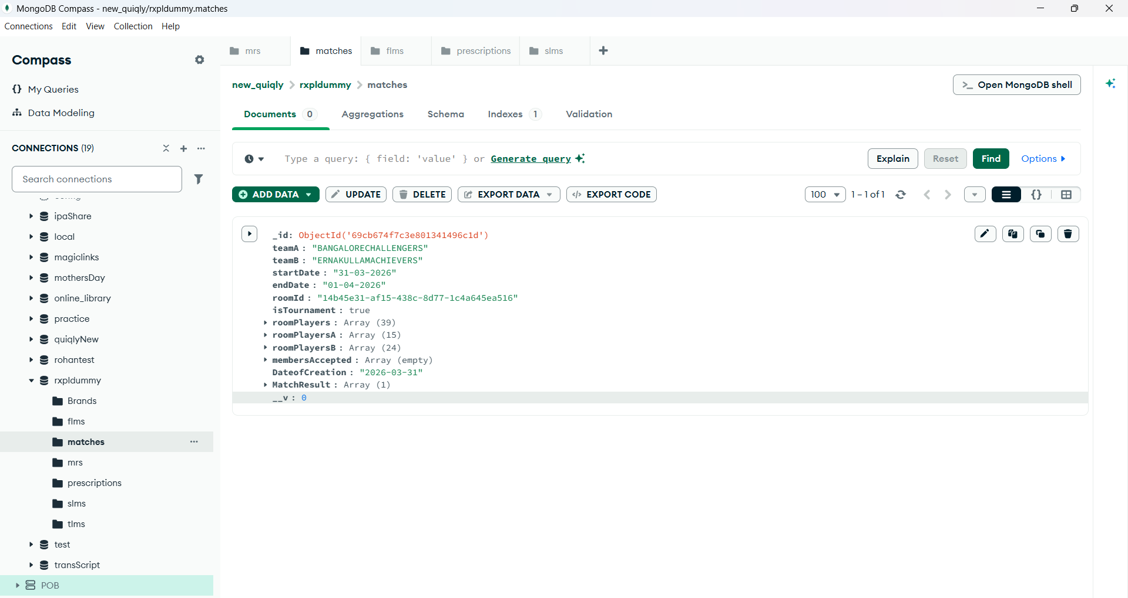

- Create the TeamA for playerID-A and TeamB for playerID-B with the given StartDate and EndDate , As well as Create roomID with uuid library, isTournament, roomplayers with all players get combine of two teams , roomplayersA and roomplayersB too, memberAccepted, DateofCreation and MatchResult for it

Step 3: Create Connection of MR from Matches and make Active

- 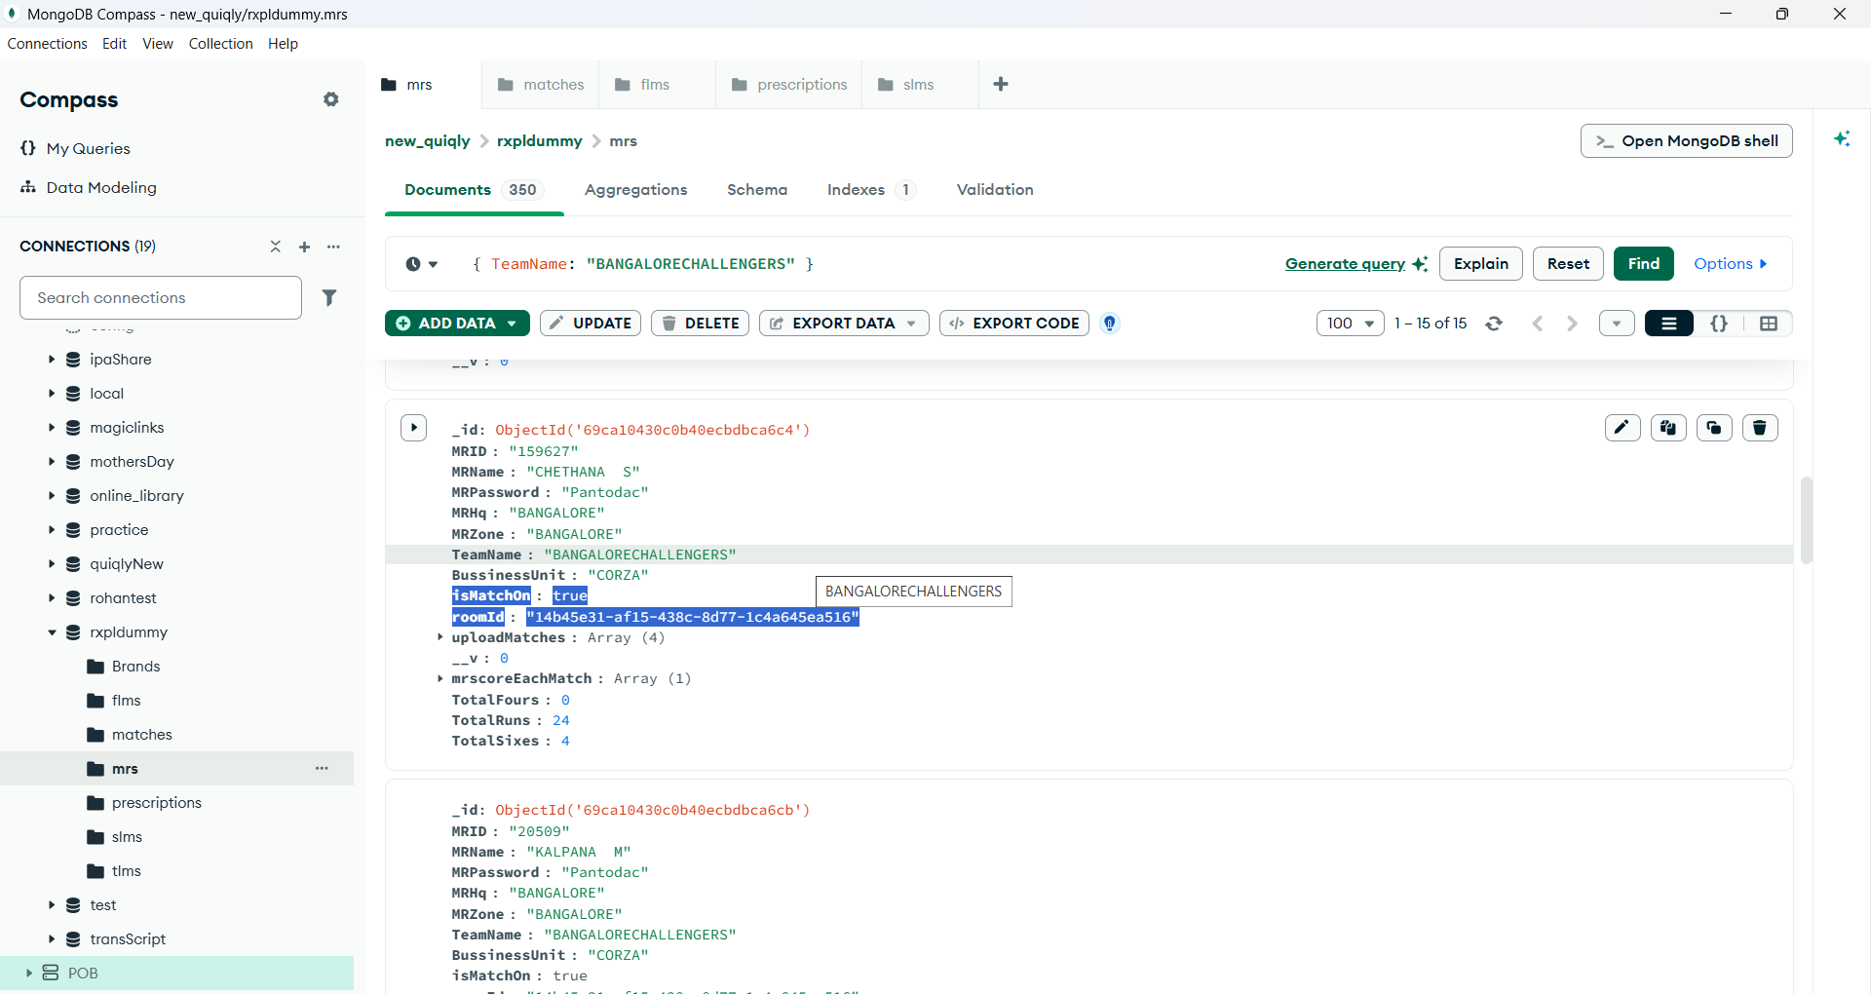

- Just create the Connection of SLM with their MR whose matches are live and if they are live , then give the same roomID to their MRs and give the isMatchOn = true .

- If no match is live , then give it by default False , rest ignore about the below things

Step: 5: If match is Live , then send the prescription
- Create new API with the create-prescription and get the objectID of MR .
- Put the MR objectID in params, and get the roomID of MR , and go in the matches and compare the roomID of MR and Matches both
- IF the roomID of MR match with the current Match , then Send the Prescritpion in the body
- And make a new field in MR named Upload-Matches and add that prescription in that array field.

Step 6 : Get the Brand with Points and Get the teamScore with their Results.
- Create a Schema Named as Brands and add 2 things
- BrandName: Brand A
- Points : 6

- BrandName : Brand B
- Points: 4
- Now create a field in MR named as totalRuns , totalSixes and TotalFours

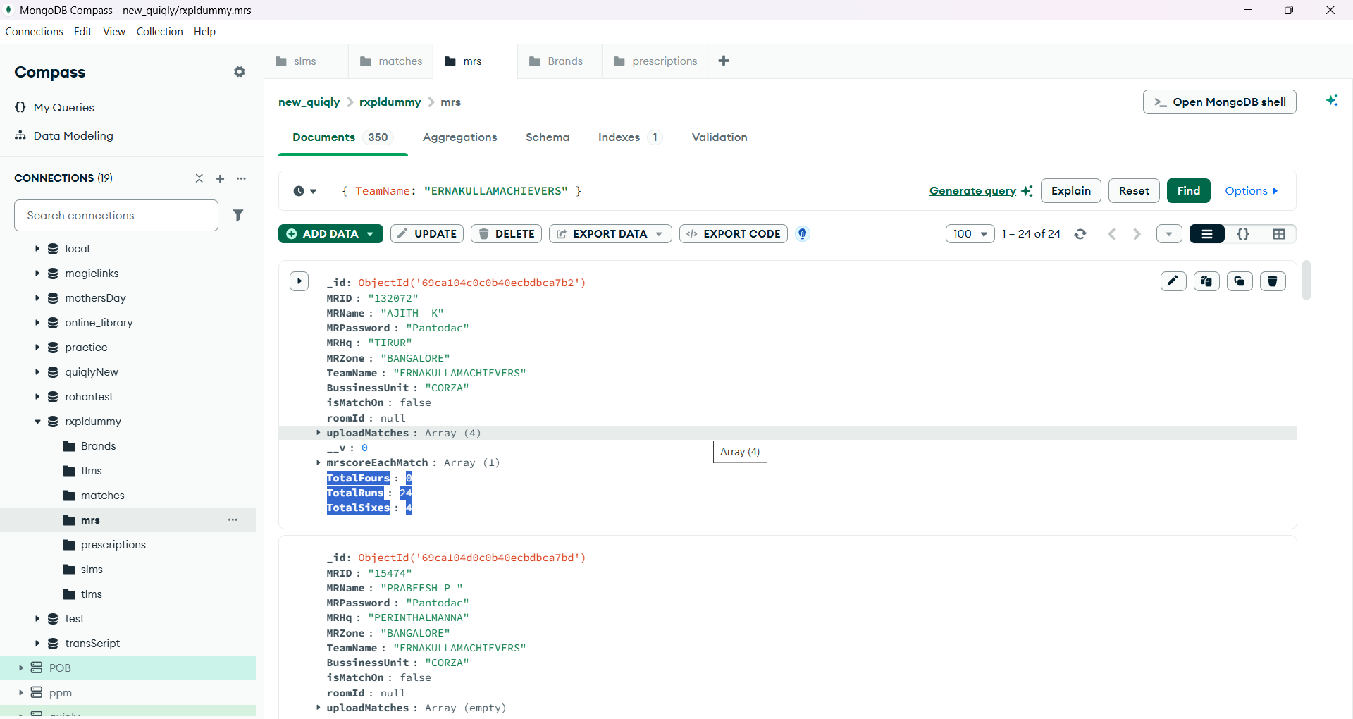

- Now create a field in Matches too named as TeamA Name , TeamAScore,
TeamB Name, TeamBScore and Results
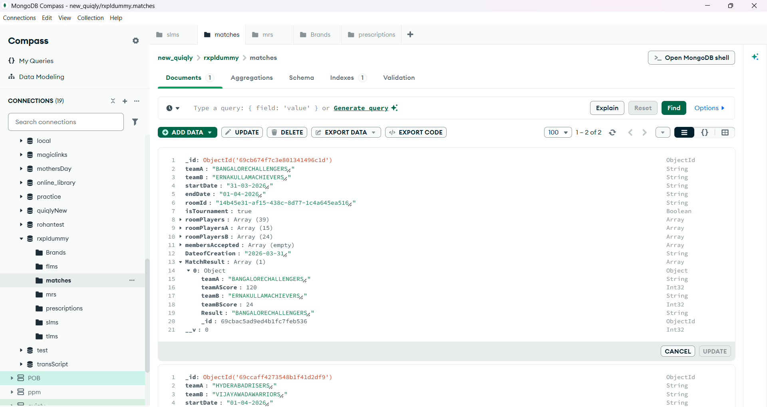
- Now add this BrandName as Brand in Prescription in the req.body with it

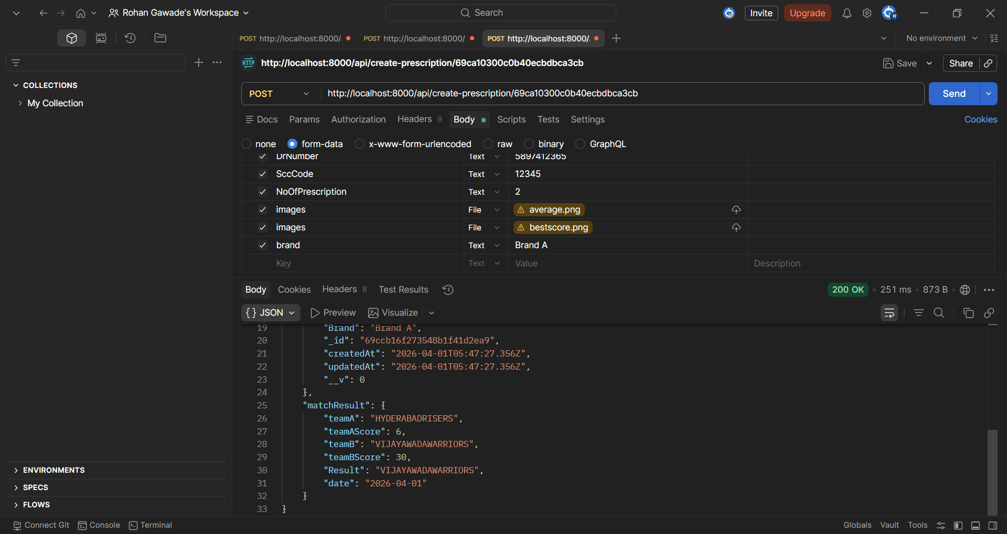

- In this Scenario , Attach the Brands to Prescription and whenever in req.body I call the Brand A or B , it should upload the TotalRuns with it TotalSixes or TotalFours Respectively for their Specific MR objectIDs.

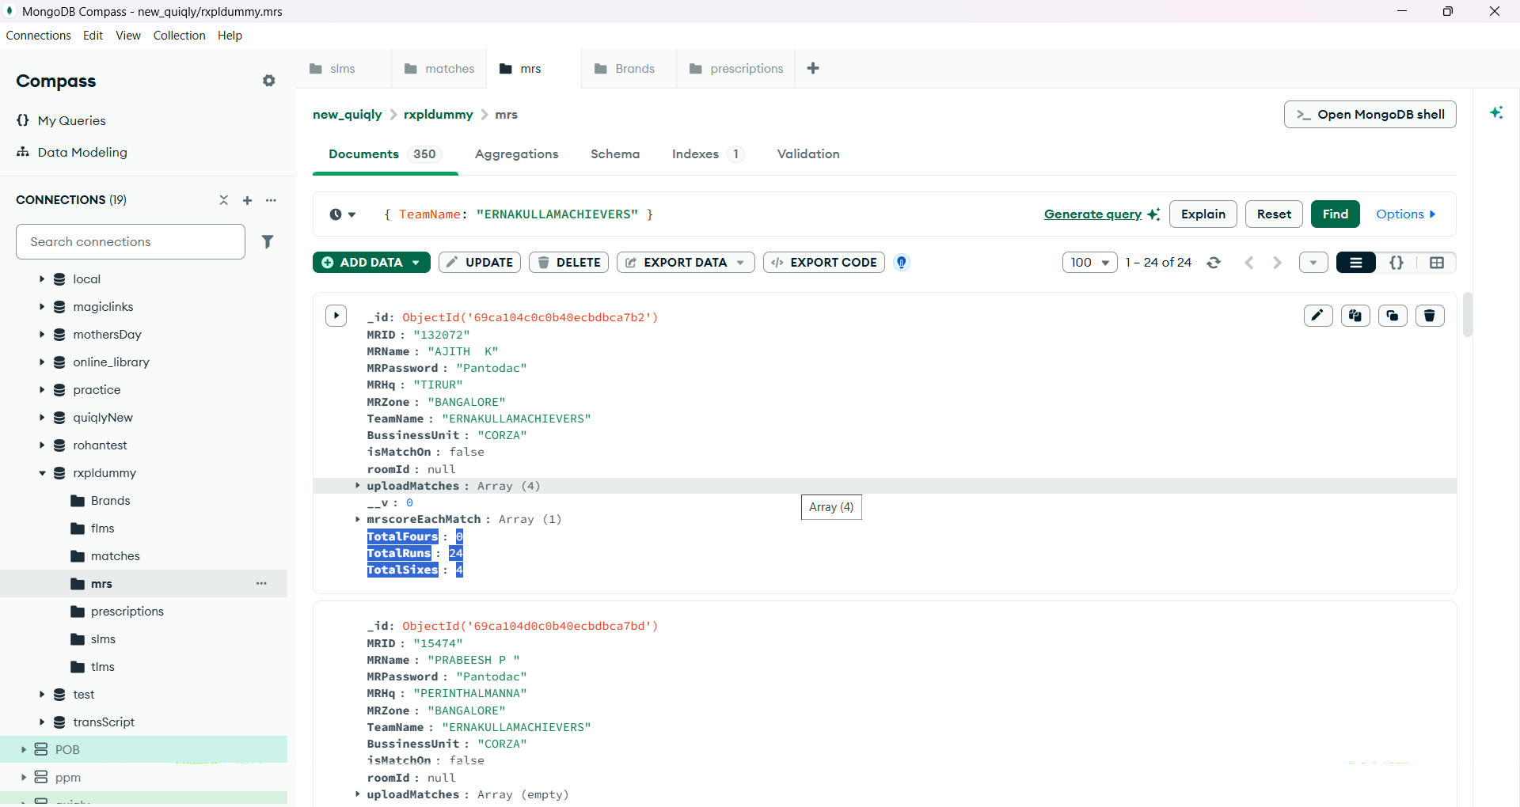

- If the MR objectID is from TeamA in the Prescription , then it should update with the TeamA Name and the TeamAScore (TotalScore)
- Either if it is TeamB MR then it should update with the Same for it with the TeamB Name and TeamBScore (TotalScore)
- At the End , think the logic for the Result and compare the both team Scores and show the Result with showing their TeamNames in it respectively

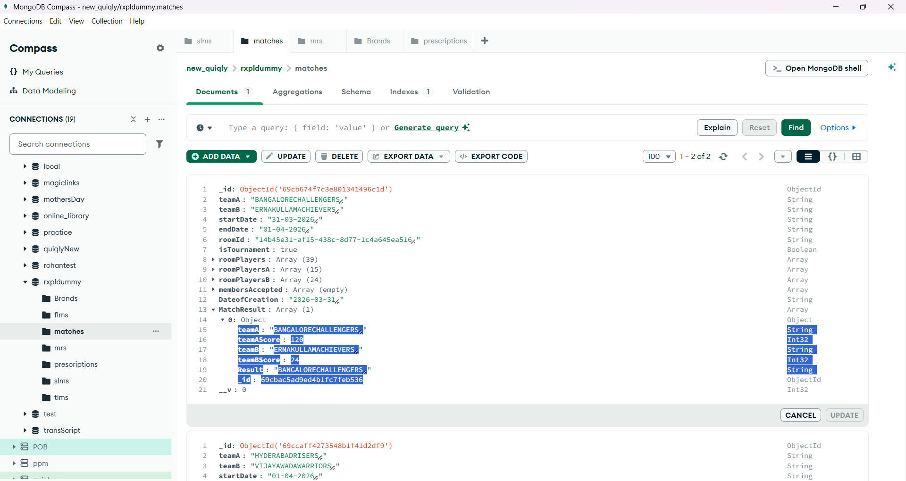
Step 7: Get the MRScoreEachMatch for it in the MR schemas

- Create the Schema in MR Field named as MrScoreEachMatch
- Get the MatchID , roomID , startDate, endDate , results and stats with it s runs , sixes and fours

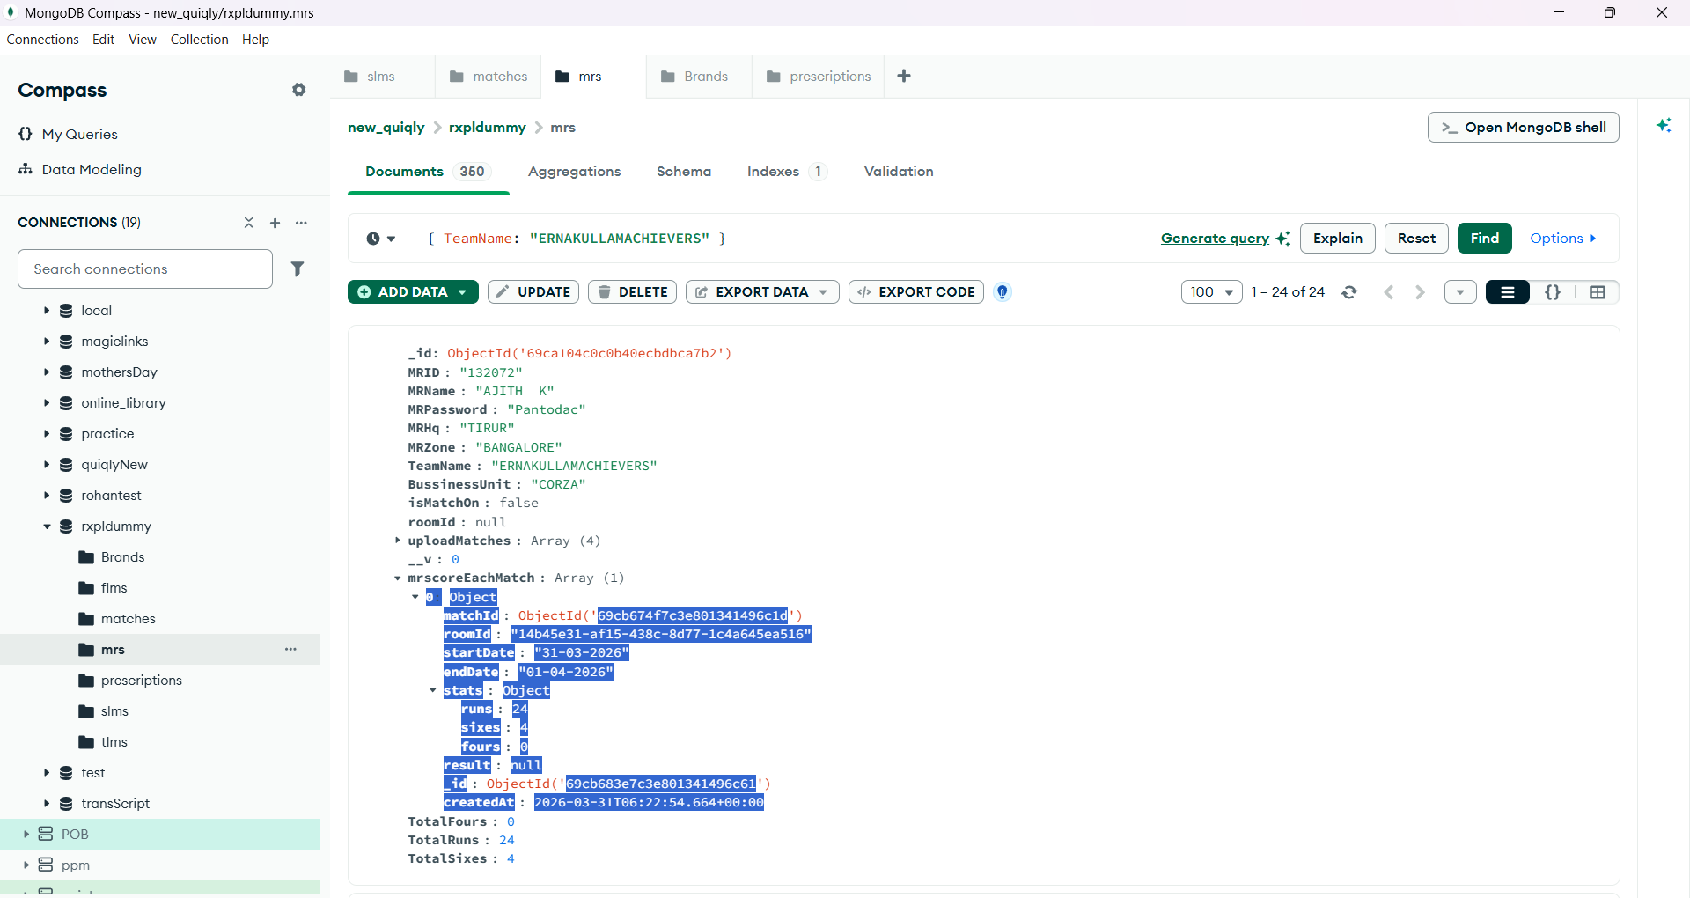

- Now in this , After getting the schema , go into the prescription and get the matchID from the matches and the roomID too, so that , we can find that , at which match , which MR has played with their specific personal runs , sixes and fours through their matchID and startDate and EndDate

- If you got then , hit the API and get the personal Score for each MR in it and store into the MR Database

Step 8 : Websocket installation and show the live Data in Frontend
- Install the websocket in the project with “npm i socket.io”
- Add into the Server.js , and exchange with the local server
- Make a setup of Websocket io in the server.js and in the prescription too
- Call in the prescription with it
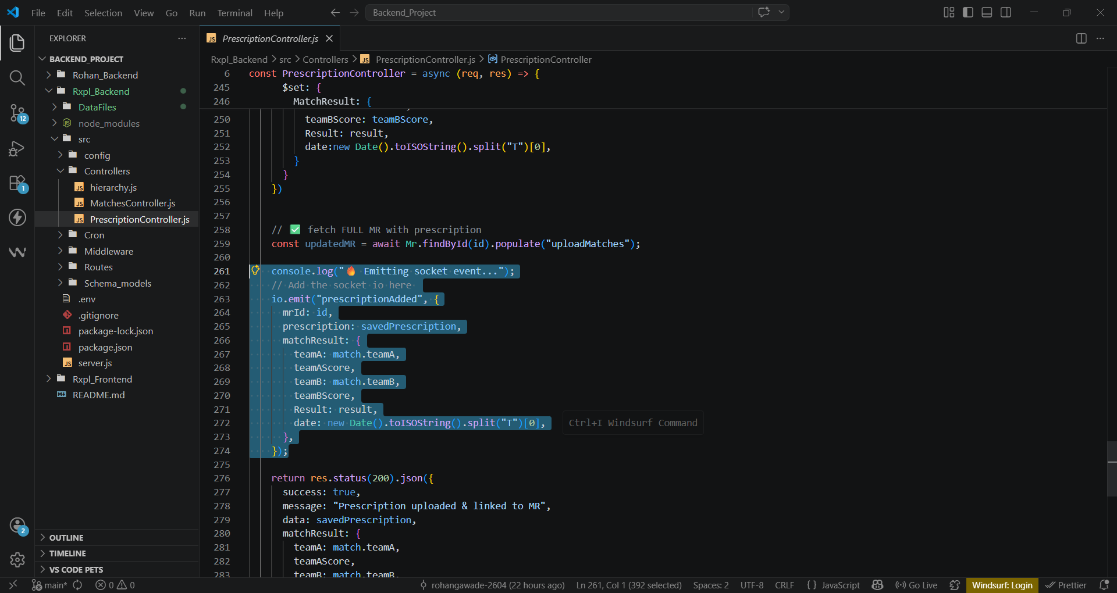
Make a frontend with React.js and attach the websocket with the frontend part and display the prescription lively in it
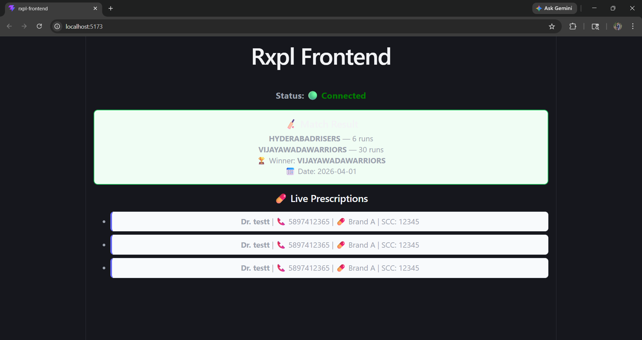

Note :- Websocket blocks the port no. 6000 , it does not runs on this port

